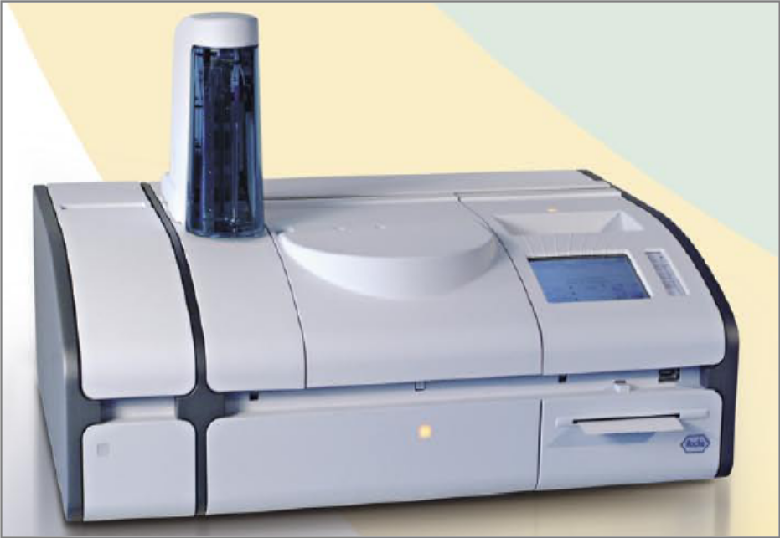

cobas c 111 system

Short Guide
Version 2.0
Table of contents
Starting the system 3
Preparing the system using the wizard 3
Checking the external fluid containers 4
Checking the ISE status 6
Performing maintenance actions 7
Preparing the reagents 9
Checking the cuvettes 10
Performing calibrations 10
Defining orders 11
Monitoring the progress 11
Validating patient results 12
Performing calibrations 13
Performing QC measurements 14
Performing Default QC 14
Performing interval QC measurements 15
Finishing the shift 16
Checking for unfinished samples 16
Checking for non-validated results 16
Checking for non-transmitted results 16
Performing the daily backup 17
Exporting the full results 17
Cleaning up the database 17
Replacing cuvettes 18
Emptying the waste 18
Removing the reagent disk 18
Logging off the system 18
Switching off the system 18
Selected actions 19
Deproteinizing the probe 19
Priming the fluid system 19
Performing electrode service 20
Performing ISE calibration 21
Replacing ISE fluids 22
Replacing electrodes 23

Starting the system
Make sure the external fluid containers are connected to the instrument.
- Switch on the instrument.
- Choose Overview > Logon and type your user name.
- Press 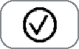 and type your password.
- Press .
Preparing the system using the wizard
- Choose Overview > Prepare.
- When you have finished a task, press  to proceed to the next step in the Prepare wizard.
Checking the external fluid containers
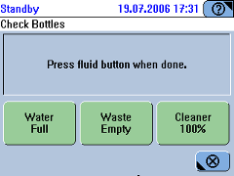
If you work outside the Prepare wizard, choose 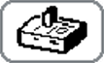 > 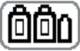.
Refilling the water, if required
- Remove the tubing adapter from the white water container and place it on a clean surface.
- Refill the bottle with NCCLS Type II water.
- Insert the tubing adapter.
- On the screen that shows the container status, press the water button to confirm that you have refilled the water.
- Empty the waste container (see below).
Emptying the waste container, if required
- Have the spare waste container ready.
- Remove the tubing adapter from the yellow waste container and insert it in the spare container.
- Remove the bottle from the rack and place it on a firm and even surface.
- Place the spare container on the rack.
- Insert the tubing adapter.
- On the screen that shows the container status, press the waste button to confirm that you have emptied the container.
- Empty the removed waste container. Treat its content as biohazardous waste.
- Rinse the container with water and leave it to dry.
- When you have dealt with all external fluid bottles, press to proceed to the next step in the Prepare wizard.
Replacing the cleaner bottle, if required
The cleaner button tells you how much cleaner is left.
- Remove the tubing adapter from the cleaner bottle and place it on a clean noncorrosive surface.
- Dispose of the bottle.
- Remove the cap from the new bottle.
- Place the new bottle on the rack.
- Insert the tubing adapter and press it down firmly.
- On the screen that shows the container status, press the cleaner button to confirm that you have exchanged the cleaner bottle.
- When you have dealt with all external fluid bottles, press to proceed to the next step in the Prepare wizard.
Checking the ISE status
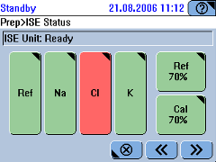
If you work outside the Prepare wizard, choose Overview > 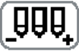.
Replacing the ISE fluid bottles, if required
The bottle buttons tell you how much fluid is left in the bottles.
- Press <Cal> if you want to replace the ISE Calibrator indirect/urine bottle, or press <Ref> if you want to replace the ISE Reference Solution bottle.
- Open the ISE cover.
- Remove the tubing adapter by lifting it and placing it on a clean lint-free tissue.
- Remove the bottle.
- Remove the cap of the new bottle.
- Place the new bottle on the instrument.
- Insert the tubing adapter.
- Close the ISE cover.
- On the screen, press <Cal> if you just replaced the ISE Calibrator indirect/urine bottle, or press <Ref> if you just replaced the ISE Reference Solution bottle.
 | You need to calibrate all ISE tests before you can process orders. This will be done later in the Prepare wizard, together with all other calibrations.

Performing maintenance actions
Completing maintenance actions correctly and on time helps to ensure smooth and uninterrupted operation of your instrument.
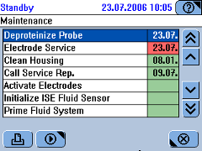
If you work outside the Prepare wizard, choose Utilities > Maintenance.
- Select the maintenance action you want to perform.
- Press .
The first screen of the wizard for performing the selected maintenance action is displayed. Usually, this is the maintenance description screen.
- Follow the instructions on the screen.
- When you have performed all required maintenance actions, press to proceed to the next step in the Prepare wizard.
Maintenance actions and their intervals
Interval | Maintenance action
None (Initiated by other maintenance actions.) | Activate Electrodes
None (Initiated by other maintenance actions.) | Condition ISE Tubing
None (Initiated by other maintenance actions.) | Initialize ISE Reference Sensor
None (Initiated by other maintenance actions.) | Abs. Air/Water Calibration
None (Initiated by other maintenance actions.) | Prime ISE Reference and Cal.
Daily | Deproteinize Probe
Daily | Electrode Service
Daily | Prime Fluid System
Weekly | Clean ISE Tower Automatically
Weekly | Clean Probe Manually
Monthly | Clean ISE Tower Manually
Monthly | Clean Reagent Disk
Monthly | Initialize ISE Unit
Three-monthly | Clean Water and Waste
Three-monthly | Replace Water Inlet Filter
Six-monthly | Clean Housing
Six-monthly | Replace ISE Unit Tubing
Six-monthly | Replace ISE Pump Tubing
Six-monthly | Replace Photometer Lamp
Yearly | Call Service Rep.

Preparing the reagents
If you work outside the Prepare wizard, choose Overview > >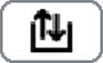
Loading the reagent disk
- Open the main cover.
- Place the reagent disk in the reagent cooler.
Make sure the reagent port faces the front and align the cut-outs with their counterparts on the reagent cooler.
- Close the main cover.
Replacing reagents
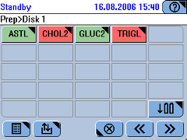
- Press a reagent button to check the details.
- Press .
- Open the main cover
- Remove the bottle.
- Press to confirm.
- Remove the remaining bottles of the set.
- Press 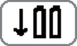.
- Scan the bottle barcode.
- Place the new bottle.
- Press to confirm.
- Load the remaining bottles of the set.
- When you have replaced all reagents, press to proceed to the next step in the Prepare wizard.
Checking the cuvettes
Replace all red cuvette segments.
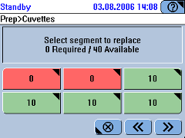
- Press the button of the cuvette segment you want to replace.
- Open the main cover.
- Remove the cuvette and treat it as biohazardous waste.
- Insert the new cuvette segment.
- Press to confirm the replacement.
(Press 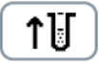 if you removed the segment without replacing it.)
- Replace the remaining segments.
- When there are enough empty cuvettes, press to proceed to the next step in the Prepare wizard.
Performing calibrations
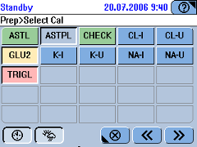
By default, all tests whose calibration is due or will be due within the forecast period are automatically selected. You can cancel these selections by pressing 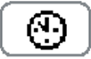, 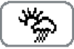 or a test button.
See Performing calibrations on page 13.
Defining orders
- Identify the sample.
If | Do this
You work with sample barcodes: | Use the barcode scanner to scan the barcode.
You do not work with sample barcodes or if the barcode could not be read for some reason: | Press .  Type the sample ID, then press .  Type the order ID, then press .  This step is only required if the configuration setting [Order ID = Sample ID] is Off.
- Select the tests.
- Place the sample on any free position on the sample are. (You have 10 seconds to do so.)
- Press  to start processing.
Monitoring the progress
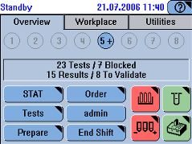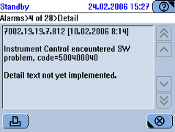
- Watch the buttons on the [Overview] tab, particularly the sample tube buttons.
Press a sample tube button to display information on the sample.
- Watch out for alarm messages.
Press  to display alarm messages.
Validating patient results
- Display the results
If | Do this
The sample is still on the sample area: | On the [Overview] tab, press the sample button.
The sample is no longer on the sample area: | Choose Workplace > Result Review.  Select the result.
- Press 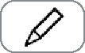.
- Do one of the following:
- Press <Repeat> to re-perform the test using the same dilution.
- Press <Rerun> to re-perform the test using a predefined dilution.
- Press <Accept> to accept the result.
- Press <Retransmit> to send the result to the host again. Use this function if you suspect that the result has not been stored properly on the host system, for example because of a communication problem.
Performing calibrations
- Choose Workplace > Calibrations >  to start the wizard.
- Select the tests.
Press to select all tests that currently need calibrating.
Press to select all tests that will be due within the forecast period.
Press a test button to calibrate this test.
- On the screen, check which calibrators are required, prepare them and place them on the positions indicated on the screen.
- Press to confirm the placement.
- Press to start the calibration.
- Validate the calibration results. (Calibration results must be accepted before they are used by the system.)
- Choose Workplace > Calibrations.
- Select the result and press .
- Do one of the following:
- Press <Accept> to accept the calibration results for the selected test.
- Press <Repeat> to have the calibration performed again.
- Press <Use Old> to override and reset the calibration due date and to continue using the old calibration results.
- Remove the calibrators from the sample area.
Performing QC measurements
Performing Default QC
Performing Default QC follows a streamlined procedure whereby QC orders are automatically defined as soon as you identify a control. An order is defined for all tests for which this control is defined as the Default QC, provided the test is currently active on the system.
- Choose Overview > Order > 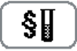.
- Prepare the controls.
- Press a control button and place the control tube on any free position on the sample area.
- Place the remaining controls in the same manner.
- When all controls are placed, press to start processing.
- Validate the QC results.
- Choose Workplace > QC Status.
- Select the result and press .
- Do one of the following:
- Press <Accept> to accept the QC results for the selected test.
- Press <Ignore> to continue working with the old QC results.
- Press <Retransmit> to send the result again.
- Remove the controls from the sample area.
Performing interval QC measurements
- Choose Overview > Order > 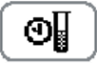
or choose Workplace > QC Status > .
- Press a test button to select a single test or press to select all tests for which QC is due.
- Prepare the controls.
- Press a control button and place the control tube on any free position on the sample area.
- Place the remaining controls in the same manner.
- When all controls are placed, press to start processing.
- Validate the QC results.
- Choose Workplace > QC Status.
- Select the result and press .
- Do one of the following:
- Press <Accept> to accept the QC results for the selected test.
- Press <Ignore> to continue working with the old QC results.
- Press <Retransmit> to send the result again.
- Remove the controls from the sample area.
Finishing the shift
Checking for unfinished samples
- Choose Workplace > Orders.
- Choose  > Not finished.
- Press .
A screen is displayed that contains all unfinished orders.
Checking for non-validated results
- Choose Workplace > Result Review.
- Choose > Not Accepted.
- Press .
A screen is displayed that contains the patient results that have not been accepted yet.
- Validate the results.
- Select the result and press .
- Do one of the following:
- Press <Repeat> to re-perform the test using the same dilution.
- Press <Rerun> to re-perform the test using a predefined dilution.
- Press <Accept> to accept the result.
Checking for non-transmitted results
This task is only required if you work with a host system.
- Choose Workplace > Result Review.
- Choose > Not Sent to Host.
- Press .
- Select a result.
- Press .
- Press [Retransmit].
Performing the daily backup
The cobas c 111 instrument can store orders and result data for one working day. It is therefore necessary to export to an external medium all data that you need to keep.
During a database export, the full content of the database is copied to the USB stick. The database data can be restored to the instrument if required (Utilities > Import > Database).
- Choose Overview > End Shift.
- Press 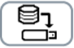.
- Insert the USB stick.
- Select the directory.
- Press .
- Press to proceed to the next stage in the End Shift wizard.
Exporting the full results
When exporting results, the patient, QC, and calibration results are copied to the UBS stick.
- Press .
- Insert the USB stick, if you have removed it.
- Select the directory.
- Press .
- Press to proceed to the next stage in the End Shift wizard.
Cleaning up the database
The cobas c 111 instrument can store orders and results data for one working day. It is therefore necessary to delete results and orders to ensure that there is enough space on the system for the next shift.
By deleting the patient results, you delete the corresponding order as well.
- Press 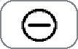.
The following results will be deleted:
- Accepted patient results.
- QC results that were accepted are deleted from the QC Status list (they remain in the QC History).
- QC results that were generated before the first day of the previous month are deleted from the QC History.
- Obsolete calibration results (results that are no longer associated with a valid lot).
- Press to confirm the deletion.
- Press to proceed to the next stage in the End Shift wizard.
Replacing cuvettes
See Checking the cuvettes on page 10.
Emptying the waste
See Emptying the waste container on page 4.
Removing the reagent disk
Perform this task if your shift was the last.
- Choose Overview > > .
- Open the main cover.
- Remove the reagent disk.
- Place the reagent disk in the reagent disk container.
- Close the main cover.
- Store the reagent disk container in a refrigerated place.
Logging off the system
Choose Overview > button with your user name.
Switching off the system
Press O on the toggle switch.
Selected actions
Deproteinizing the probe
- Prepare one tube each with Activator and ISE Deproteinizer.
- Choose Utilities > Maintenance.
- Select the maintenance action [Deproteinize Probe].
- Press .
The maintenance definition screen is displayed.
- Press .
A placement list is displayed.
- Place the Activator and ISE Deproteinizer on the positions indicated on the screen.
- Press to confirm the placing.
The system first deproteinizes and then activates the probe.
- When the maintenance action is complete, remove the tubes.
- Press 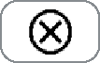.
Priming the fluid system
- Check the external water and waste containers. If required, refill the water and empty the waste container.
- Choose Utilities > Maintenance.
- Select the maintenance action [Prime Fluid System].
- Press .
- The maintenance definition screen is displayed.
- Press to start the action..
- The system performs the priming actions automatically.
- A message will tell you when the maintenance action is complete.
- When the maintenance action is complete, press .
You need to prime the fluid system when the system detects air whilst priming water/ when the water gets finished during a run..
Performing electrode service
- Prepare one tube each with Activator, ISE Deproteinizer, and ISE Etcher.
- Choose Utilities > Maintenance.
- Select the maintenance action [Electrode Service].
- Press .
The maintenance definition screen is displayed.
- Press to start the action.
A placement list is displayed.
- Place the Activator, ISE Deproteinizer, and ISE Etcher on the sample area positions indicated on the screen.
- Press to confirm the placement and to start the action.
A message will tell you when the maintenance action is complete.
- When the maintenance action is complete, remove the Activator, ISE Deproteinizer, and ISE Etcher from the sample area.
- Press .
You need to calibrate all ISE tests before you can process orders.
See Performing ISE calibration on page 21.
Performing ISE calibration
The following is a convenient way of performing ISE calibration when the calibrations are due. See also Performing calibrations on page 13.
- Choose Overview > .
- Press .
- Place the calibrators on the positions indicated on the screen.
- Press .
- Press to start the calibration.
- Validate the calibration results.
Choose Workplace > Calibrations.
Select a result and press .
Do one of the following:
- Press <Accept> to accept the calibration results for the selected test.
- Press <Repeat> to have the calibration performed again.
- Press <Use Old> to override and reset the calibration due date and to continue using the old calibration results.
- Remove the calibrators from the sample area.
Replacing ISE fluids
- Check that the system is in Standby status.
- Choose Overview > .
- Check the status of the ISE bottles.
- Press <Cal> if you want to replace the ISE Calibrator indirect/urine bottle, or press <Ref> if you want to replace the ISE Reference Solution bottle.
- Open the ISE cover.
- Scan in the barcode on the reagent bottle
- Remove the tubing adapter by lifting it and placing it on a clean lint-free tissue.
- Remove the bottle.
- Remove the cap of the new bottle.
- Place the new bottle on the instrument.
- Insert the tubing adapter.
- Close the ISE cove.
- Press to perform the actions that are required as a consequence of changing the electrode.
- Place the solutions on the sample area positions as indicated on the screen.
- Press to confirm the placement and to start the action.
The system performs the [Electrode Service] maintenance action.
- When a message tells you that [Electrode Service] is complete, press to perform the calibration.
- Remove the ISE fluids from the sample area.
- Press .
- Validate the calibration results.
- Choose Workplace > Calibrations.
- Select a result and press .
- Do one of the following:
- Press <Accept> to accept the calibration results for the selected test.
- Press <Repeat> to have the calibration performed again.
- Press <Use Old> to override and reset the calibration due date and to continue using the old calibration results.
Replacing electrodes
- Check that the system is in Standby status.
- Choose Overview > .
- Check the status of the electrodes.
- Press the button of the electrode you want to replace.
- Press to start the exchange wizard.
You are asked to remove the electrode. (Make sure to remove the electrode that is marked on the screen.)
- Open the ISE cover.
- Open the electrode block lid.
- Release the tension lever.
- Remove the electrode.
- On the screen, press the electrode button to confirm that you have removed the electrode.
You are asked to scan the barcode of the new electrode or to type its ID manually.
- Scan the electrode barcode on the package insert or type the ID manually.
If a dummy electrode is scanned, a screen is displayed, asking you to select the electrode that will be replaced by the dummy electrode.
You are asked to insert the new electrode.
Always replace an electrode with the same type or with a dummy electrode. (The Reference electrode must always be replaced with another Reference electrode. Dummy is not allowed.)
- Insert the new electrode.
Push it back towards the contacts and press it down until it clicks into place.
- Fasten the tension lever.
At this stage, if you want to replace another electrode, press its button and replace it as described above.
- Close the electrode block lid.
- On the screen, press the electrode button to confirm that you inserted the electrode.
A screen is displayed that shows detailed information on the electrode.
Press .
- Close the ISE cover.
- On the ISE status screen, press to continue the process.
A placement list is displayed.
- Place the Activator, ISE Deproteinizer, ISE Etcher, ISE Solution 1, and ISE Solution 2 on the sample area positions indicated on the screen.
- Press to confirm the placement and to start the action.
The system performs the [Electrode Service] maintenance action.
A message will tell you when the maintenance action is complete.
- When the action is complete, press to perform the calibration.
- Validate the calibration results. (See Performing calibrationson page 13.)
- Remove the Activator, ISE Deproteinizer, ISE Etcher, ISE Solution 1, and ISE Solution 2 from the sample area.

